Internet Speed Test

Document Name: Internet Speed Test Guideline

Document Version: 1.0

Open-Source Document

Release date: 22nd July 2024

Author: Anjan Chandra

Table of Contents

**1.** **Speed Test – Cloudflare** 2

**2.** **Speed Test – Google** 3

**3.** **Speed Test – nPerf** 4

**3.1 nPerf Speed Test – EMA / EU** 5

**3.2 nPerf Speed Test – US** 6

**3.3 nPerf Speed Test – ASPAC** 6

**4.** **AWS – Latency Test** 8

**5.** **Azure – Latency Test** 9

**6.** **Azure Download Test using PowerShell** 10

## **Speed Test – Cloudflare**

Perform Speed Test from Cloudflare ([Internet Speed Test - Measure Network Performance | Cloudflare](https://speed.cloudflare.com/)

Go to [Internet Speed Test - Measure Network Performance | Cloudflare](https://speed.cloudflare.com/) and click on Start / Restart

Take a capture full page.



## **Speed Test – Google**

Perform Speed Test from Google ([Internet Speed Test | Check Broadband Speed | Google Fiber](https://fiber.google.com/speedtest/))

Go to [Internet Speed Test | Check Broadband Speed | Google Fiber](https://fiber.google.com/speedtest/) and click on GO

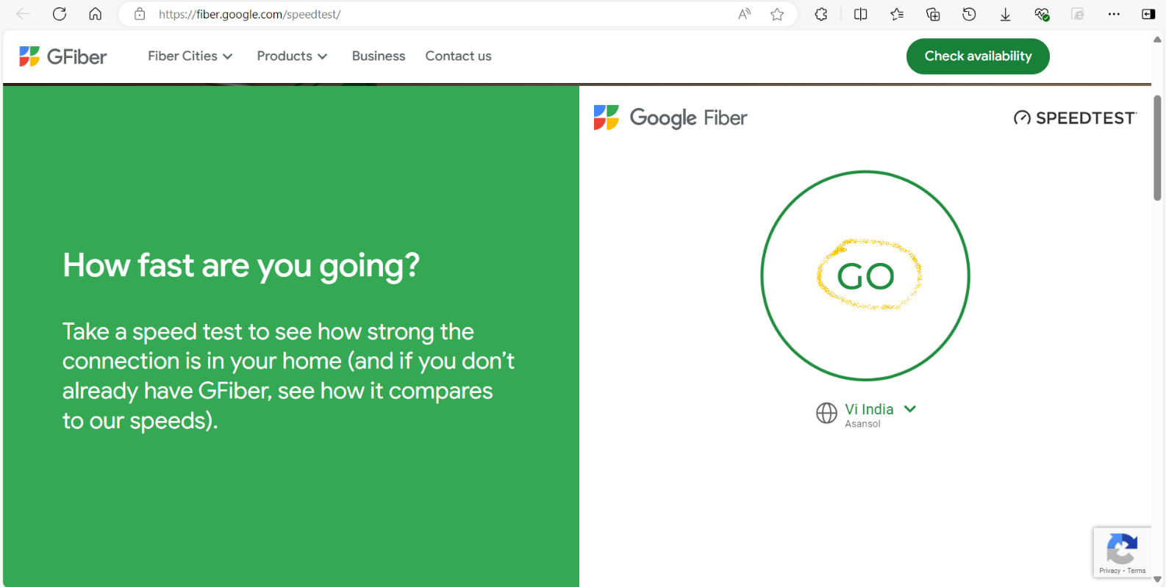

## **Speed Test – nPerf**

Perform SpeedTest from nperf ([Internet Speed test : Test your broadband connection (speedtest) - nPerf.com](https://www.nperf.com/en/))

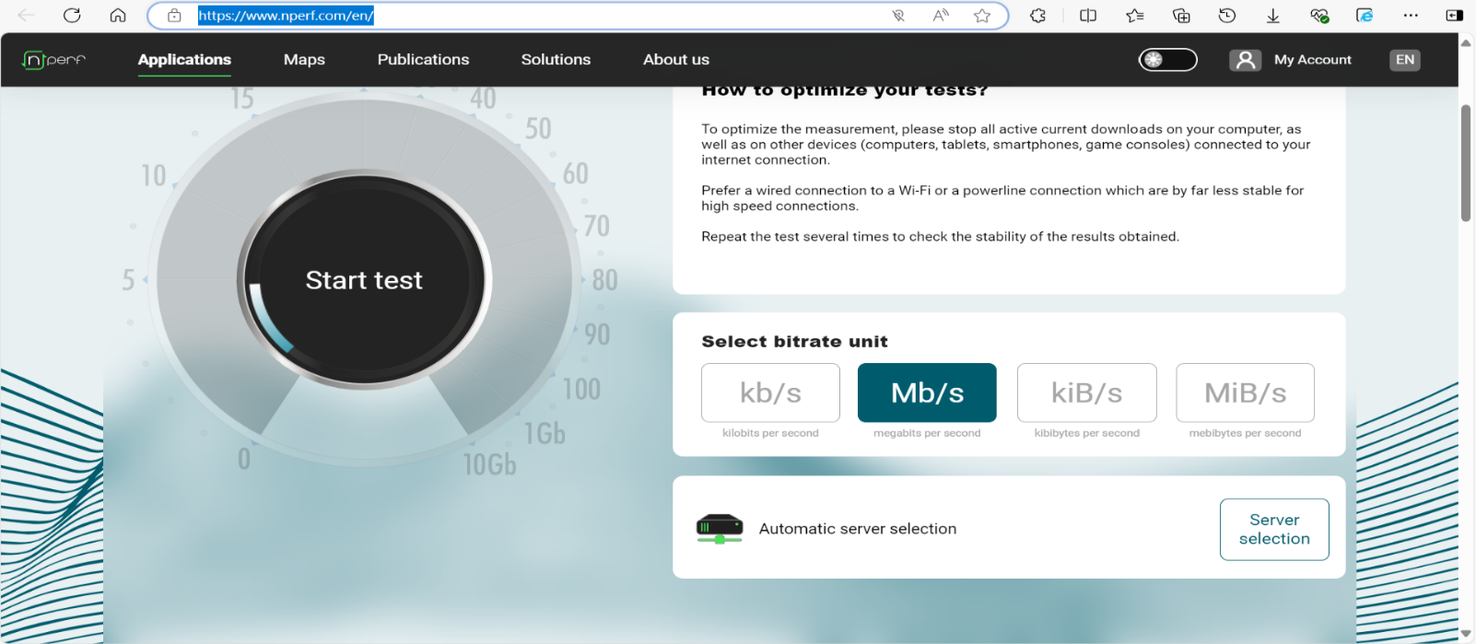Go to [Internet Speed test : Test your broadband connection (speedtest) - nPerf.com](https://www.nperf.com/en/) and click on Start Test

You would get a result like below. Take a screenshot.

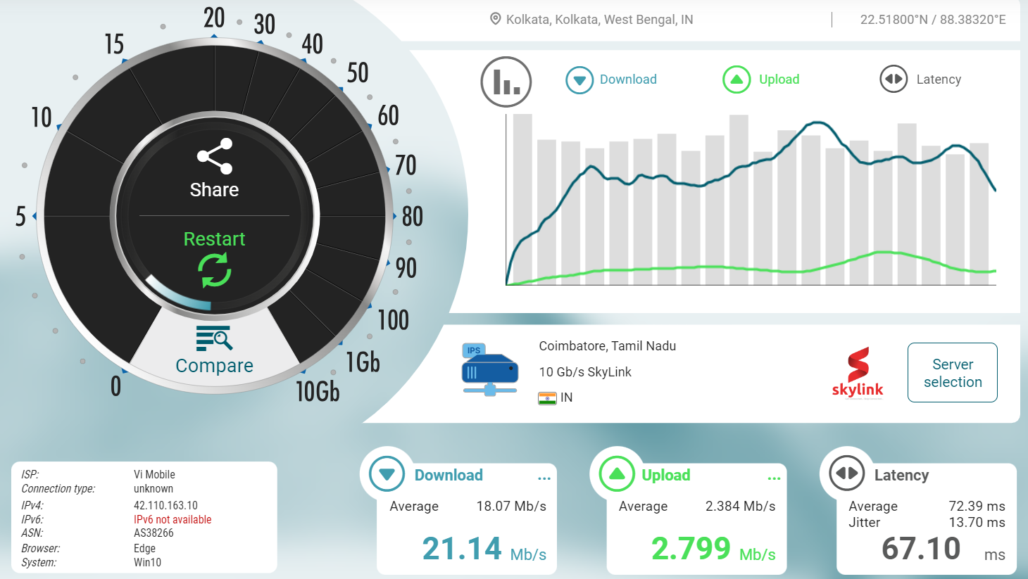

Additionally, you must choose 3 servers from 3 different regions (AMS, EU, ASPAC) and run another 3 tests. You can choose alternative server if the one you chose doesn’t work for you.

Click over the Server Selection Option

### **3.1 nPerf Speed Test – EMA / EU**

**Test for EU / Europe / Netherlands / Amsterdam or any other city**

Search “[NL]” and choose any of the available options from Netherlands and run the test. If the server doesn’t work for you then, repeat the step and choose another option from Netherlands.



### **3.2 nPerf Speed Test – US**

**Test for US / USA / Verizon**

Search “[US]” and choose any of the available options from Verizon and run the test. If the server doesn’t work for you then, repeat the step and choose another option from USA.



### **3.3 nPerf Speed Test – ASPAC**

**Test for ASPAC / Singapore / DataPackets**

Search “[SG]” and choose any of the available options from Verizon and run the test. If the server doesn’t work for you then, repeat the step and choose another option from USA.

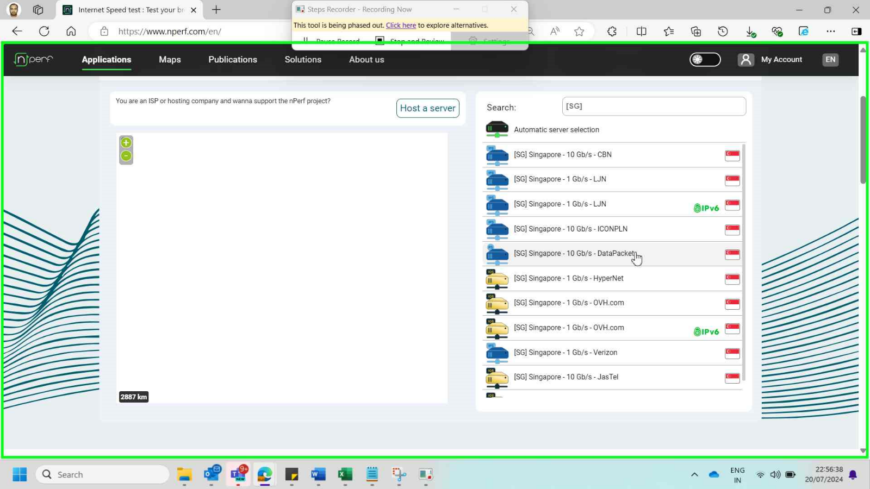

## **AWS – Latency Test**

AWS Latency Test - [AWS Latency Test (awsspeedtest.com)](https://awsspeedtest.com/latency)

This tool runs latency test from your IP location to AWS datacenters around the world.



## **Azure – Latency Test**

Azure Latency Test - [Azure Latency Test - Measure Latency to Azure Datacenters Worldwide (azurespeed.com)](https://www.azurespeed.com/Azure/Latency)

Test latency from your IP location to Azure datacenters worldwide.



## **Azure Download Test using PowerShell**

Azure Download Test using PowerShell

Open powershell (Windows PowerShell ISE) and run the below script. Send the report to intended participant. The script is going to create a file name “azure_download_test.txt” and save to your download folder. The script would also open a email prompt.

Open “Windows PowerShell ISE”

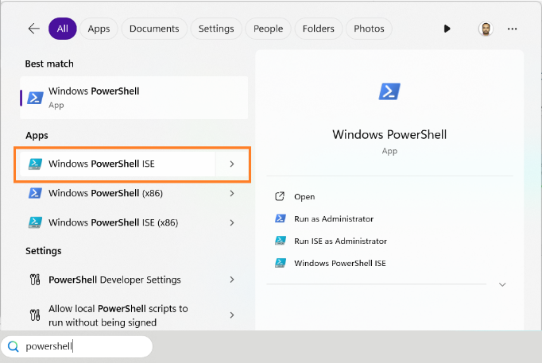

Run the below script in Windows PowerShell ISE



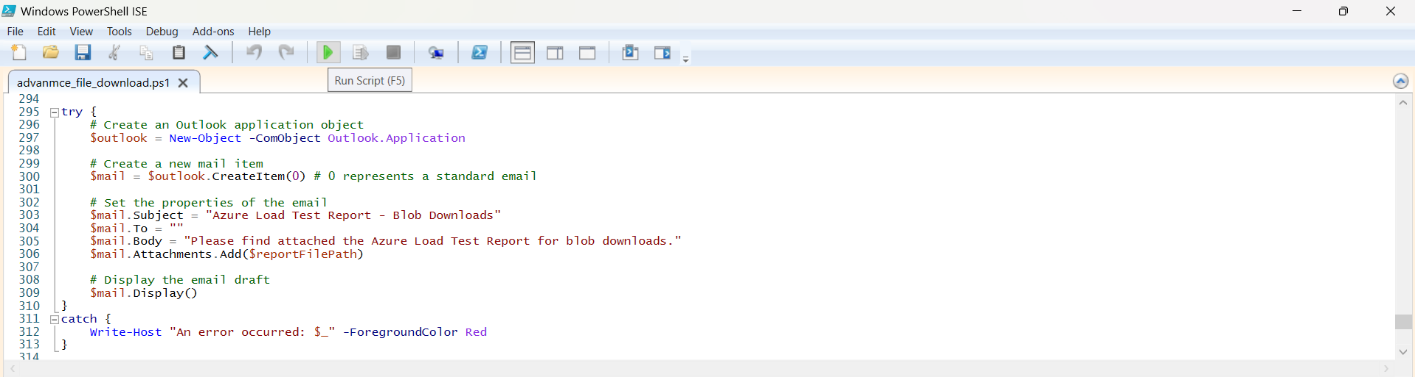

The script would take few minutes to complete the download of Azure Blob Files.

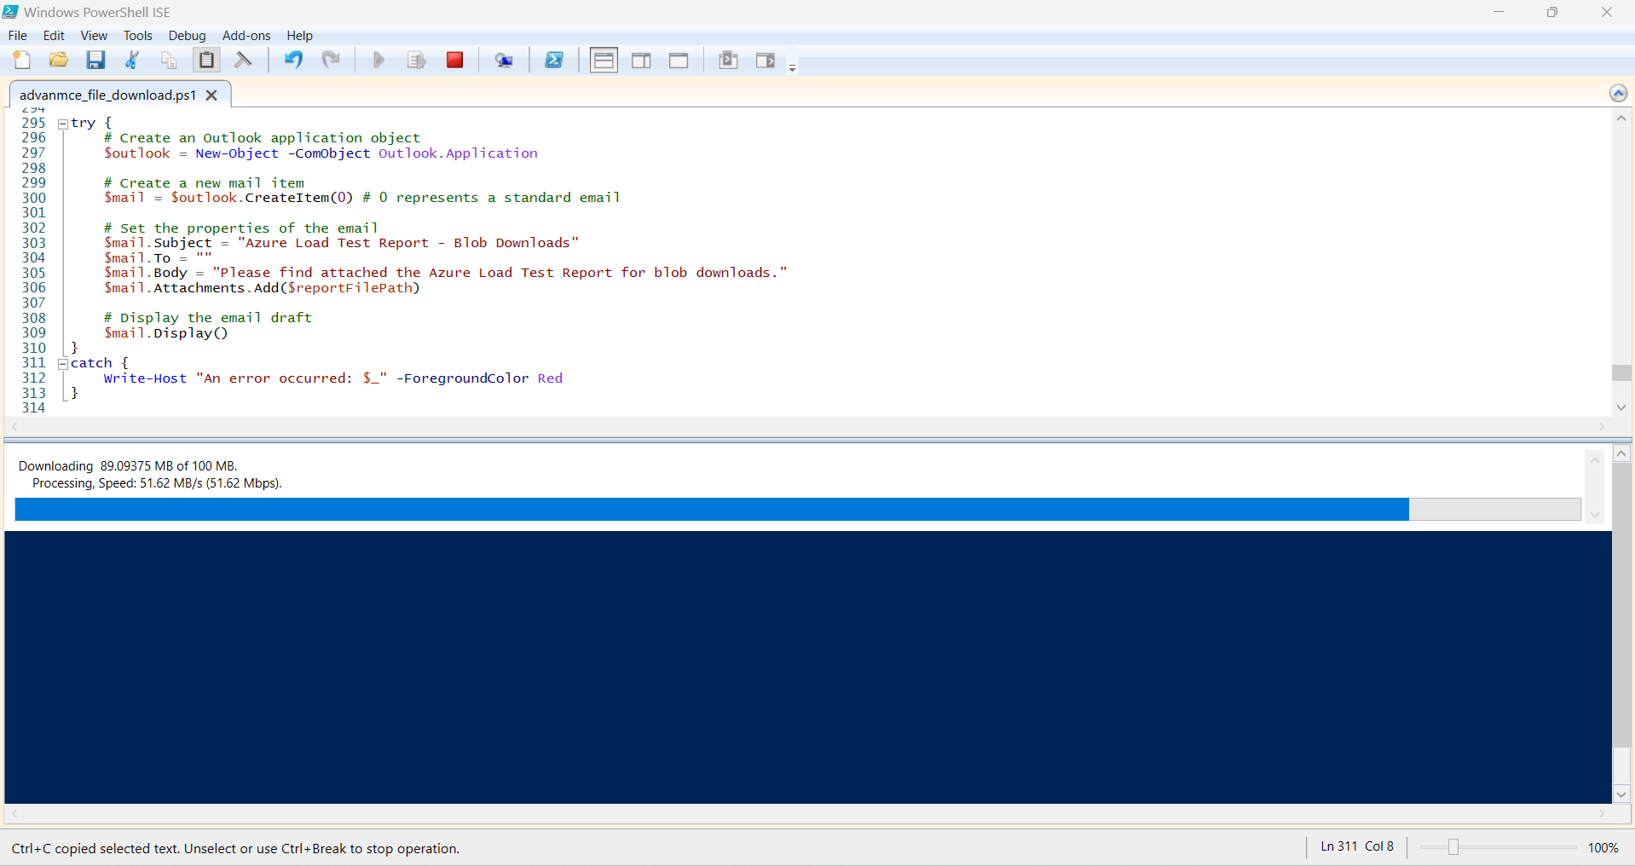

Once completed, the script would create a file named “azure_download_test.txt” and open an email prompt.

